Connecting to and setting up Sharc:

To connect to SHARC open an terminal type in **ssh -X username@SHARC.sheffield.ac.uk** remembering to replace the username:



*Top Tip: to copy and paste in linux terminal use* ***ctrl+shift+c*** *or* ***v****.* ***ctrl+c*** *kills anything running in the terminal*

Put in your password and you should be meet with text similar to this:

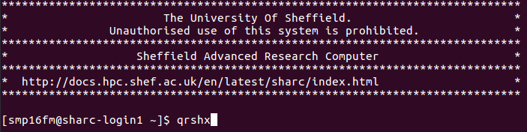

Next type in **qrshx** as shown above**,** this opens an interactive node that allows users to use text editors such as gedit and other wonderful things. For more information about options with qrshx see the following link: <http://docs.hpc.shef.ac.uk/en/latest/hpc/scheduler/qrshx.html>

SHARC comes with a load of models that you can chop and change between. If you type **module avil** it will list all available models on SHARC.

To run MPI-AMRVAC we need an MPI library, so type:

**module load mpi/openmpi/2.1.1/gcc-6.2**

Now, type **module list,** which will give:

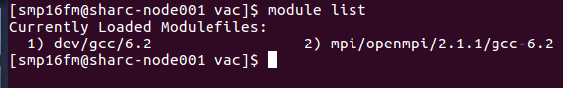

Next follow the instruction given here: <http://amrvac.org/md_doc_installation.html>

Notes:

1. For Setting Path Section in link above you need to **gedit ~/.bashrc**
2. Make sure paths match the directories you git cloned into
3. While editing the bash you can also add:

**#SHARC modules to load on launch**

**module load mpi/openmpi/2.1.1/gcc-6.2**

This means these modules will load automatically without having to manually type them in each time you open an interactive session on SHARC. You may also want to do the same for python.

1. Don’t need to close new shell after **source ~/.bashrc** (I think)

Running first test case:

To run the first case go through the following instructions: <http://amrvac.org/md_doc_getting_started.html>

Once you do **mpirun,** open paraview while waiting. When you code is finished running, type **ls** in the terminal. You will notice you now have files with .dat and .vtu extensions. The dat files are the raw data stored in binary format and vtu files are formatted to be read in Paraview. On your local machine open a new terminal and create a new directory (e.g. **mkdir amrvac_data**), then create another directory (e.g. **mkdir amrvac_data/vac_sim**) for good file management. Go to your newly created directories and copy the vtu or vtk files on your local machine, which can be done with the following (remember to replace **usrname**):

**scp -r** [**usrname@SHARC**](mailto:usrname@SHARC.sheffield.ac.uk)**:/home/usrname/codes/amrvac/tests/rho/vac/*.vtu .**

The **\*** in this situation is a wild card and will pick up all files with the vtu in their name. The **.** means it will copy in your current location.

Notes:

1. Location of the first test case is: **amrvac/tests/rho/vac/**
2. Don’t need to worry about the **arch** flag, leave this blank.
3. When you first run **make** the whole of MPI-ARMVAC is compiled. You may run into errors if you do  **make -j 4**